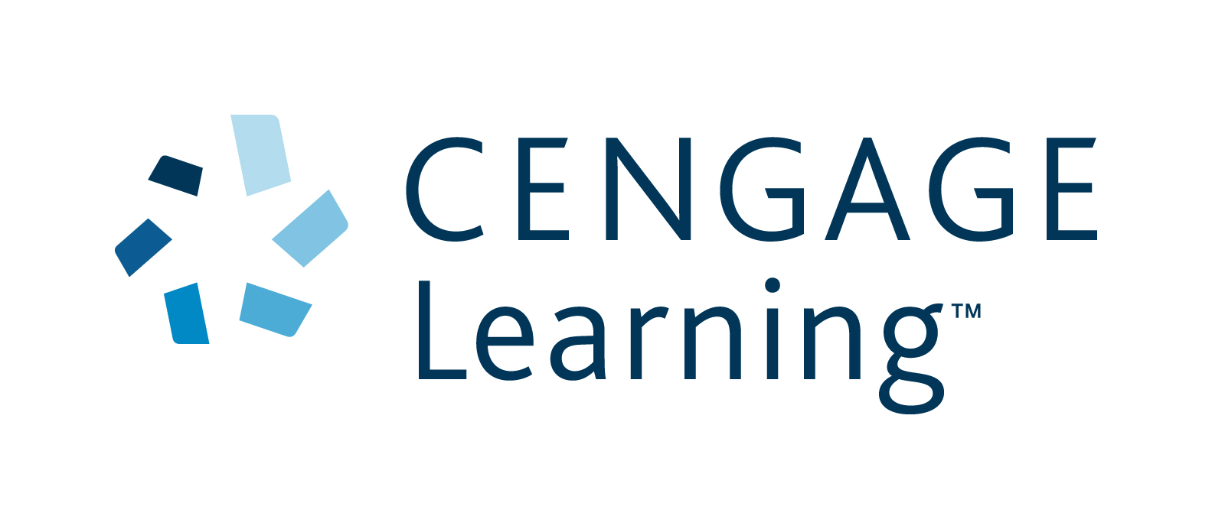

POSITION DESCRIPTION

Name: TBA

Job title: Senior Editor, Secondary

Date: November 2013

Department: Secondary Editorial

Reports to: Managing Editor

Basic purpose:

The Senior Editor will manage the pre-press stages of Secondary titles, including print, audio, video and digital products. This includes co-ordinating the work of freelance editors, co-ordinating audio and video sessions, and liaising with illustrators and multimedia developers.

Principal accountabilities:

Key Outcome and Area | % of Total Job | Objectives and Tasks | Core Competencies | Standards
Project-manage the editorial processes for print and digital products | 50% | - Work closely with the Publishing Editors to prepare clear and reliable briefing documents for inhouse designers and multimedia developers to create sample designs for approval.  - Work closely with the Publishing Editor to prepare clear and reliable briefing documents for inhouse designers and multimedia developers to accompany final content from authors and contributors.  - Brief and manage freelance editors and proofreaders on projects.  - Ensure high editorial standards are met and titles meet agreed publishing specifications.  - Ensure editorial costs fall within prescribed budgets.  - Organise, schedule and oversee audio recording sessions and video shoots for supplementary material, including sourcing talent.  - Liaise with in-house designers and multimedia developers during production processes for print and digital products, assessing their work as required.  - Any other duties as directed by the Managing Editor, Secondary. | - Proven and excellent editorial and proofreading skills  - Ability to visualise design outcomes and anticipate problems when giving editorial instructions  - Project management skills  - Ability to manage a demanding and complex workload by prioritising urgent tasks while keeping all other aspects of the job under control  - Understanding user expectations and current conventions of print and digital products  - Ability to problem-solve and manage complex and/or numerous projects to an agreed timeline  - Good judgement and timely decision-making to prioritise work and effort  - Knowledge of the publishing processes involved in preparing integrated educational packages that contain a complex mixture of language, pictures, audio, video and interactive material  - Excellent written and spoken communication skills  - Facility with Outlook, MS Word, MS Excel and PowerPoint.  - Interpersonal skills with the ability to work within a close knit team | - Project delivered on time and within budget  - Briefing documents produced  - Minimal communication problems due to effective communication  - Feedback provided  - Customer-first focus  - Professional approach to delivering content to the standard and on time  - Friendly, proactive communication  - Accuracy  - Standard of Freelancers  - Freelancers maintaining CLA standards  - A positive attitude to problem-solving  - Going the extra mile to achieve the best possible outcome  - Sharing ideas and learning in a team environment  - Control of expenses in line with budget and business needs
Editorial duties | 10% | - As and when schedules allow, edit selected projects (print and multimedia) to maintain skill base and experience of required work across the department.  - Perform a range of editorial duties within Cengage editorial guidelines, including:  - copy editing and structural editing  - proofreading, and managing external proofreaders  - liaising with authors, consultants and publishers  - commissioning and briefing designers, illustrators and photographers  - liaising with internal and external designers, and typesetters  - working with internal and external multimedia developers  - liaising with production controllers  - Follow editorial department procedures and maintain records as required. | - Excellent written and verbal communication skills  - Proven and excellent editorial and proofreading skills.  - Meticulous attention to detail  - Understand colleagues’ roles and tailor the communication meets their needs and achieve desired outcomes.  - Negotiation and interpersonal skills with the ability to build relationships.  - Ability to visualise design outcomes and anticipate problems when giving editorial instructions  - Good judgment and timely decision-making to prioritise work and effort  - Ability to prioritise urgent tasks, and keep all aspects of the job under control  - Well-developed computer skills, including onscreen editing and experience working with MS Office applications  - Knowledge of InCopy, Filemaker and Acrobat Pro  - Excellent knowledge of English grammar  - Knowledge of current book and multimedia production technology and procedures | - Customer-first focus  - Friendly, proactive communication  - A positive attitude to problem-solving  - Accuracy  - Projects delivered on time and within budget and to standard  - Author relationship  - Adherence to CLA policies and procedures
Communicate regularly on editorial progress | 10% | - Keep the Managing Editor informed of the status of all titles in the Secondary list.  - Attend cross-functional Work in Progress meetings organised by the Editorial Department and provide updates on editorial progress for each title.  - Liaise proactively with the Publishing Editor to anticipate and solve problems.  - Contribute to continuous improvement and follow editorial departmental procedures and maintain records as required. | - Ability to organise detailed and complex information so that others can deal with it effectively  - Excellent communication skills  - Understand colleagues’ roles and tailor the communication meets their needs and achieve desired outcomes. | - Meeting participation and attendance  - Customer-first focus  - Friendly, proactive communication  - A positive attitude to problem-solving
Communication and teamwork | 10% | - Contribute to editorial forums and share information and knowledge with colleagues.  - Communicate and liaise with colleagues in other functional areas.  - Proofread and check the accuracy of material prepared by the marketing department for Secondary department titles. | - Ability to listen and understand editorial aims  - Contribute to discussion in a friendly, clear manner  - Problem-solving abilities with keen attention to detail and follow through | - Friendly, proactive communication  - Sharing ideas and learning in a team environment  - Shows respect for others
Continuous Improvement | 10% | - Support Lean Six Sigma Process owners in the audit process.  - Support Green Belts in your division on projects related to your area.  - Keep abreast with the continual change in technology developments and share knowledge with manager and team.  - Seek opportunities to enhance documentation, processes and supported systems to improve processes and procedures.  - Actively seek opportunities to extend and enhance personal knowledge and skills in order to better support customers and colleagues. | - Problem-solving abilities with keen attention to detail and follow through  - A willingness to support and help others | - Continuous improvement and improved efficiency  - Self initiated training and development of knowledge  - Demonstrated initiative for issue resolution and new ideas to add value to users  - Participation and contribution of processes improvement projects  - A positive attitude to problem-solving
Workplace Health and Safety | 10% | - Be aware of duty of care and act in a safe manner.  - Ensure all company WH&S policies and procedures are adhered to.  - Be familiar with property security, first aid and fire emergency procedures.  - Report any hazardous situations, incidents or accidents and take immediate action if applicable to reduce risk of injury.  - Participate in WH&S investigations when required. | - Ability to follow policies and procedures  - Ability to use initiative and take responsibility  - WH&S aware  - Analytical and problem-solving abilities | - Adherence to WH&S policies and procedures  - Increased WH&S awareness  - A positive attitude to WH&S  - Reduction of number of WH&S incidents

Direct reports: None, however the Senior Editor liaises with freelance editors, proofreaders, designers, illustrators, typesetters and indexers as required.

Main contacts:

Internal: Managing Editor, Publishing Editors , Publishing Manager, senior editors, editors and supplements editors, multi-media, production controllers, designers, permission researchers, Marketing Manager, Sales Manager, sales representatives, Human Resources, Finance

External: Authors, teachers, curriculum officers, freelance editors, proofreaders, designers, illustrators, indexers, answer checkers, photographic researchers, freelance permissions researchers

Education / Qualifications / Experience:

- Appropriate tertiary qualification
- Experience in a commercial educational publishing role, especially with complex, highly illustrated and designed material
- Teaching experience or a teaching qualification would be an advantage
- Knowledge of a language other than English would be an advantage

Cengage Core Competencies:

- Drive for results – the ability to set and exceed personal and team goals, pushes self for results
- Customer focus – dedicated to meeting the expectations and requirements of internal and external customers. Establishes and maintains effective relationships with customers and gains their respect
- Leading change – can effectively cope with change, make decisions and act without having the total picture
- Creativity – identifies new and unique opportunities and ideas
- Interpersonal savvy – relates well with others throughout the organisation, builds rapport, diffuses difficult situations
- Collaboration – works with others in the organisation to achieve collective goals.

